LANDIS-II Visualization Tool v1.0
Extension User Guide for
Modelers and Developers

Johannes Liem
Helen Jenny
Melissa S. Lucash
Robert M. Scheller

Oregon State University
Portland State University

Table of Contents

Pre-Processing Tool 3
1 Introduction 3
2 Guide to Using the PreProcTool 3
2.1 Introduction 3
2.2 Installation 3
2.3 Uploading Data 4
2.4 Downloading an Example 5
2.5 Configure the project xml file for PreProcTool (preproc_example_project.xml) 5
2.6 Run the PreProcTool (run_preproctool.bat) 12
2.7 Examining the Output from the Pre-Processing Tool 13
2.8 Output folder 13
3 Examples 15
3.1 Example 1 15
3.2 Example 2 16
3.3 Example 3 17
LandisVis Development 19
1 Development environment of PreProcTool 19
2 LandisVisualizationDevel folder 19
3 How to build the WebVisTool and PreProcTool 20
4 How to create the MSI-Installer 21
4.1 Settings in advanced installer 22
4.2 Building an installer 25

Pre-Processing Tool

Introduction
This document describes the pre-processing tool for the Visualization Tool for the LANDIS-II model. It also describes the underlying code for the tool for programmers seeking to modify the code. For information about the LANDIS-II model and its core concepts including succession, see the LANDIS-II Conceptual Model Description and the LANDIS-II website (www.landis-ii.org).
This manual is to be used in conjunction with the user’s guide for the visualization tool.

Guide to Using the PreProcTool

Introduction
The LANDIS-II PreProcTool is a command line tool to generate a web application to visualize LANDIS-II model data (http://www.landis-ii.org).

Installation
Download the MS I-Installer LandisPreProcToolInstaller.msi from the LANDIS google code repository or github.
https://github.com/LANDIS-II-Visualization/LandisVisualizationInstaller

User’s tip: For the installation to work correctly, you have to use a windows administrator account
- Double-click the installer
- Click Next
- Select an install destination ore use the default install folder > Next
- Click Install
- This may take several minutes
- User Account Control pop-up: click Yes
- Click Finish

You can only install one version of the pre-processing tool on your machine. If for some reason, you need to install a new version, you have to uninstall the old one.
- Open the Control Panel > Programs and Features
- Select LandisPreProcTool
- click Uninstall
- click Yes
- User Account Control pop-up: click Yes
Or:
- Run the Installer
- click Next
- click the Remove Icon
- click Remove
- User Account Control pop-up: click Yes
- click Finish

Uploading Data
If you want to create a link (website), where others can view the data, you need to upload all your data (e.g. LANDIS output) to a server. For example, we use FileZilla to upload all our files. In FileZilla:
- File > Site Manager … (CTRL+S)
- click New Site button
- choose a name (e.g. landis-vis)
- General Tab:
- Host: research.pdx.edu
- Protocol: SFTP – SSH File Transfer Protocol
- Logon Type: Normal
- User: PSU ODIN username
- Password: PSU ODIN password
- Advanced Tab:
- Default remote directory: /vol/www/landis-visualization
- Connect
- On the right side you see the local file-structure; on the left side you see the server file-structure
- With right-click > upload or drag-and-drop you can upload files/folder to the server (or download to your computer)The user makes sure that each folder contains all the data from a scenario (i.e. one folder for each scenario).
If you only want to view your data locally (i.e. on your own computer), you do not need to upload the data to a server and can just access the data on your hard drive.

Downloading an Example
Download example_project.zip
https://github.com/LANDIS-II-Visualization/LandisVisualizationInstaller
This archive contains:
- LANDIS-II scenario output folder (used extensions: Base Wind, Leaf Biomass Harvest, Output Leaf Biomass Reclass)
- run_preproctool.bat
- preproc_example_project.xml

Configure the project xml file for PreProcTool (preproc_example_project.xml)
The project xml file contains all important configurations for the PreProcTool. To change or update the configuration, open the file in a text editor (Notepad, Notepad++, Sublime Text, jEdit, ...). For your own projects use this example project xml file as a template and change the configuration based on your project and data.

Project name
Choose a short name which describes your project. This Name will be displayed in the WebVisTool header.
<landisPreProcProject projectName="Name of a Forest">

Scenarios
For every scenario you want to include into the WebVisTool, use a scenario element:
Important: All included scenarios have to have the same outputs and extensions! Otherwise the WebVisTool won't work properly.
Attributes of scenario element:
- inputPath: relative (to xml file) or absolute path to the LANDIS scenario folder
- displayName: this name is used in the menu within the WebVisTool
<scenarios>
<scenario inputPath="example_scenario_1" displayName="baseline climates" />
<scenario inputPath="example_scenario_2" displayName="climate change"/>
<scenario inputPath="C:\Landis\scenario_5" displayName="bussines as usual"/>
</scenarios>
Note: To comment a scenario use: <!-- ... --> around the scenario element. It is not going to be included in the WebVisTool. If you want to use it later again, just remove the comment elements.
<!--<scenario inputPath="example_scenario_2" displayName="climate change"/>-->

Spatial Reference
Here you have to provide information about the projection/datum and extent used by the ecoregion raster. Important: Therefore the ecoregion raster file has to have a proper spatial reference assigned!
Attributes for projection element:
- proj4: the Proj4 string contains Information about the used projection and datum
Attributes of extent element:
- ulx: x-coordinate of upper left corner of raster (value is in the unit of the used projection)
- uly: y-coordinate of upper left corner
- lrx: x-coordinate of lower right corner
- lry: y-coordinate of lower right corner
<spatialRefernce>
<projection proj4="+proj=utm +zone=15 +datum=NAD83 +units=m +no_defs " />
<extent ulx="293234.718" uly="5314517.522" lrx="566034.718" lry="5104517.522" />
</spatialRefernce>

If you don’t have the projection and extent information, you can use the Proj4Extent tool which is installed with the PreProcTool.
If the PreProcTool is installed correctly:
- GoTo: the folder where you stored the ecoregion raster used for the landis model
- make a Shift + rigth-click on the folder
- In the context menu select: Open command window here
- use the command: proj4extent.exe ecoregion.img
- replace ecoregion.img with the file name of your ecoregion raster
- press Enter to execute the command
- if everything went ok, you should see following information (the values will differ based on your ecoregion raster):
  - proj4="+proj=aea +lat_1=43 +lat_2=48 +lat_0=34 +lon_0=-120 +x_0=600000 +y_0=0 +datum=NAD83 +units=m +no_defs "
  - ulx="333923.828239" uly="1255638.5427" lrx="346623.828239" lry="1248038.5427"
- copy this two lines to your project.xml file:
  - right-click somewhere in command window > Mark with your mouse select both lines:
  - press Enter to copy the lines
  - in your project.xml file paste the lines at the bottom (Ctrl+V)
  - finally: replace the attributes of the projection and extent element by copying the strings into their places:
Before:
<spatialRefernce>
<projection proj4="+proj=utm +zone=15 +datum=NAD83 +units=m +no_defs " />
<extent ulx="293234.718" uly="5314517.522" lrx="566034.718" lry="5104517.522" />
</spatialRefernce>
After:
<spatialRefernce>
<projection proj4="+proj=aea +lat_1=43 +lat_2=48 +lat_0=34 +lon_0=-120 +x_0=600000 +y_0=0 +datum=NAD83 +units=m +no_defs " />
<extent ulx="333923.828239" uly="1255638.5427" lrx="346623.828239" lry="1248038.5427" />
</spatialRefernce>
Important: delete the two pasted lines at the end of the xml file before you save the project file. If you don't change the ecoregion file (projection and/or extent) between model runs, you can use the result for every run of the PreProcTool.

Zoom
The zoom element defines the zoom-range (min-max) of the maps in the WebVisTool. As well as the initial zoom level when starting the web application.
The valid zoom-range is between (including) 0 and 18.
Attributes of zoom element:
- min: the minimum zoom level for maps in the WebVisTool
- max: the maximum zoom level for maps in the WebVisTool
- init: the initial zoom level on start up (has to be within the range of min and max)
For just one zoom level use the same value for min, max and init.

If you don’t know which values to use for the zoom, use the Proj4Extent tool.
The Proj4Extent.exe tool calculates a value for the min zoom (3rd output line). It is based on the extent of the ecoregion map and an assumed (small) view port of the web map of 400 x 300 pixel. The values for max and init are: max = min+4 and init = min+2. For a more detailed map use a bigger max value.
Note: more and/or bigger zoom levels result in a longer run-time of the PreProcTool!
The difference between two zoom levels: An area in zoom level n is 4 times bigger in zoom level n+1. The example shows zoom level 0 and zoom level 1.

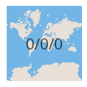
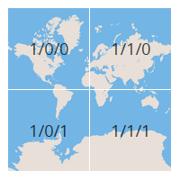
More information about web map zoom levels:
http://wiki.openstreetmap.org/wiki/Zoom_levels
https://www.mapbox.com/foundations/how-web-maps-work/
http://www.maptiler.org/google-maps-coordinates-tile-bounds-projection/

Base Map
The base map element defines the background map of the maps in the WebVisTool.
Attributes of baseMap element:
- source: for the source of the base map choose between:
- terrain: stamen terrain map http://maps.stamen.com/#terrain
- osm: open street map http://www.openstreetmap.org/
- toner: stamen toner map http://maps.stamen.com/#toner
- plain: solid background (white to black; depends on following attributes). Use this option if you use the local server (See output chapter) and there is no internet connection!
brightness: regulate brightness of base map (from -1 to 1)
contrast: regulate contrast of base map (from 0 to 2)
saturation: regulate saturation of base map (from 0 to 2)

The following figure is based on this configuration for the base map:
<baseMap source="terrain" brightness="0" contrast="1" saturation="0" />
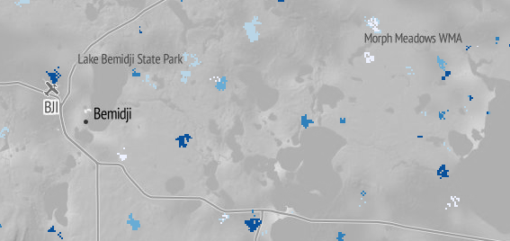

Legend
Configuration of the legend in the WebVisTool.
Attributes of legend element:
- initClassCount: the number of colors in a legend for continuous data (handles in color slider legend)
- sequentialCol: color scheme for ordinal or continuous data
- divergingCol: color scheme for diverging (minus to plus) ordinal or continuous data
- qualitativeCol: color scheme for nominal data

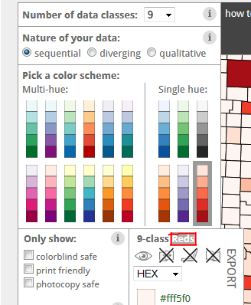
<legend initClassCount="3" sequentialCol="Reds" divergingCol="PiYG" qualitativeCol="Paired" />

The WebVisTool uses color schemes defined by Colorbrewer:
- go to: http://colorbrewer2.org/
- Select the Nature of Data
- Pick a color scheme
Copy and paste the name of the scheme into the project xml file (see the highlighted area in the figure; „Reds“)
Example:

<landisPreProcProject projectName="Example Project Name">
<input>
<scenarios>
<scenario inputPath="example_scenario" displayName="baseline climates" />
</scenarios>
<spatialRefernce>
<projection proj4="+proj=utm +zone=15 +ellps=GRS80 +datum=NAD83 +units=m +no_defs" />
<extent ulx="293234.718" uly="5314517.522" lrx="566034.718" lry="5104517.522" />
</spatialRefernce>
</input>
<output>
<map>
<zoom min="7" max="11" init="9" />
<baseMap source="terrain" brightness="0" contrast="1" saturation="0" />
<legend initClassCount="3" sequentialCol="Reds" divergingCol="PiYG" qualitativeCol="Paired" />
</map>
</output>
</landisPreProcProject>

Run the PreProcTool (run_preproctool.bat)
This batch file starts a command window and calls the PreProcTool with the parameters -p and -o.
- parameter -p (project xml file)
  - the path to the project xml-file (relative to batch file or absolute)
  - see above to learn how to configure the project xml file
- parameter -o (output folder)
  - the path of the output folder (relative to batch file or absolute)
  - the output (default: webvisoutput) generated by the PreProcTool is stored in this folder
User’s tip: If you’re planning to access the data via a server, a relative path (parameter –p) works best. Also, changing the name of the output folder (parameter –o) is extremely useful when you put the data on the server so the link will be descriptive. Otherwise your link will be servername/webvisoutput/

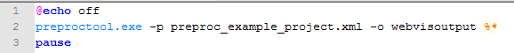
To run the PreProcTool double click the run_preproctool.bat file. For more examples of different configurations see the examples in Section 3.

Examining the Output from the Pre-Processing Tool
example_project\
|--example_scenario_1\
|--example_scenario_2\
|--webvisoutput\
|--config\
|--css\
|--img\
|--js\
|--lib\
|--index.html
|--start-landis-vis-local.exe
|--preproc_example_project.xml
|--run_preproctool.bat
|--webvisoutput.zip

Output folder
The outptut folder contains the web application LANDIS-II WebVisTool.
If you want to run the VizTool on your local Windows machine, execute the start-landis-vis-local.exe file (double-click). The WebVisTool starts up in your default web browser. If this is not Firefox or Chrome (use the current versions), open Firefox or Chrome and open http://localhost:8080/.
If you want to run the VizTool on the internet and allow others to have access to see your results, upload the entire folder (i.e. webviz output) to a server. Then you can use the viz tool using the server name/webviz_output as the website in the Viz Tool.
User’s tip for PSU staff: Once you have generated your output folder using the Pre-Processing Tool, you upload it to the PSU research server (research.pdx.edu) using FileZilla. Place the folder containing your results in the htdocs folder:
/vol/www/landis-visualization/htdocs/folder_name
Then you should be able to type this link in your browser (e.g. Firefox) and be able to use the Viz Tool to view the results.
http://landis-visualization.research.pdx.edu/folder_name
User tip: Uploading the entire folder to a server can take a while, depending on the used zoom levels, the extent of the area and the number of map outputs, a big number of little map tiles are created). One alternative is to zip the output folder, transfer it to the server and then unzip the folder (e.g. using Putty).

Change settings of the WebVisTool
A few settings that were defined in the project xml file can be changed in the default_settings.json file (webvisoutput\config\default_settings.json) after running the PreProcTool.
After making changes in the default settings.json file update the file on the server as well!
You can change the values within: projectname, playback, basemap and legend.
However DON'T change: landisdata, center, resolution, extent and resolutions!

Examples

Example 1
folder structure (BEFORE PreProcTool)
example_project\
|--example_scenario_1\
|--example_scenario_2\
|--preproc_example_project.xml
|--run_preproctool.bat

project xml file (scenarios)
<scenarios>
<scenario inputPath="example_scenario_1" displayName="baseline climates" />
<scenario inputPath="example_scenario_2" displayName="climate change" />
</scenarios>

batch file (command for starting the PreProcTool)
preproctool.exe -p preproc_example_project.xml -o webvisoutput

folder structure (AFTER PreProcTool)
example_project\
|--example_scenario_1\
|--example_scenario_2\
|--webvisoutput\
|--preproc_example_project.xml
|--run_preproctool.bat
|--webvisoutput.zip

Example 2
folder structure (BEFORE PreProcTool)
my_landis_project\
|--config_utils\
|--preproc_example_project.xml
|--run_preproctool.bat
|--scenarios\
|--example_scenario_1\
|--example_scenario_2\
|--example_scenario_3\

project xml file (scenarios)
<scenarios>
<scenario inputPath="..\scenarios\example_scenario_1" displayName="baseline climates" />
<scenario inputPath="..\scenarios\example_scenario_2" displayName="climate change" />
<scenario inputPath="..\scenarios\example_scenario_3" displayName="harvesting" />
</scenarios>

batch file (command for starting the PreProcTool)
preproctool.exe -p preproc_example_project.xml -o ..\output

folder structure (AFTER PreProcTool)
my_landis_project\
|--config_utils\
|--preproc_example_project.xml
|--run_preproctool.bat
|--output\
|--scenarios\
|--example_scenario_1\
|--example_scenario_2\
|--example_scenario_3\
|--output.zip

Example 3
folder structure (BEFORE PreProcTool)
C:\LandisModel\
|--project_oregon\
|--or_scenario_1\
|--or_scenario_2\

C:\LandisVis\
|--project_oregon\
|--oregon_project.xml
|--run_preproctool.bat

project xml file (scenarios)
<scenarios>
<scenario inputPath="C:\LandisModel\project_oregon\or_scenario_1" displayName="or base" />
<scenario inputPath="C:\LandisModel\project_oregon\or_scenario_2 displayName="or change" />
</scenarios>

batch file (command for starting the PreProcTool)
preproctool.exe -p oregon_project.xml -o output\webvistool

folder structure (AFTER PreProcTool)
C:\LandisModel\
|--project_oregon\
|--oregon_scenario_1\
|--oregon_scenario_2\

C:\LandisVis\
|--project_oregon\
|--oregon_project.xml
|--run_preproctool.bat
|--output\
|--webvistool\
|--webvistool.zip

LandisVis Development

Development environment of PreProcTool
- Python 2.7 (https://www.python.org/downloads/)
- Python modules (use the mose current win32-py2.7 version):
      - lxml 3.3.5 (http://www.lfd.uci.edu/~gohlke/pythonlibs/#lxml)
      - gdal 1.11.0 (http://www.lfd.uci.edu/~gohlke/pythonlibs/#gdal)
      - PyYaml 3.11 (http://www.lfd.uci.edu/~gohlke/pythonlibs/#pyyaml)
      - Regex 2014.05.23 (http://www.lfd.uci.edu/~gohlke/pythonlibs/#regex)
      - Pillow 2.4.0 (http://www.lfd.uci.edu/~gohlke/pythonlibs/#pillow) (PIL replacement)
      - Numpy 1.8.1 (http://sourceforge.net/projects/numpy/files/NumPy/)
      - Scipy 0.14.0 (http://sourceforge.net/projects/scipy/files/scipy/)
- PyInstaller (for freezing the application to an executable):
      - PyInstaller 2.1 (http://www.pyinstaller.org/)
      - pywin32 Build 219 (http://sourceforge.net/projects/pywin32/files/)
- Local Server (for freezing the local server script (creating an exe) use also pyisntaller)
      - CehrryPy 3.2.4 (http://www.cherrypy.org/)

LandisVisualizationDevel folder
For development purposes download the repository from GitHub:
https://github.com/LANDIS-II-Visualization/LandisVisualizationDevel
LandisVisualizationDevel\
|--Documentation\
|--PreProcTool\
|--build\
|--source\
|--test\
|--WebVisTool\
|--build\
|--localenv\
|--source\

In your local LandisVisualizationDevel folder unzip:
- PreProcTool\build\gdal-data.zip (new folder: PreProcTool\build\gdal-data\)
- PreProcTool\build\pyinstaller.zip (new folder: PreProcTool\build\pyinstaller\)

How to build the WebVisTool and PreProcTool
After you made changes in the source of the WebVisTool and/or the PreProcTool the following building steps have to be executed:

- Run the build-landis-webbase.bat (WebVisTool\build\build-lanids-webbase.bat
- Run the build_preproctool batch-file (PreProcTool\build\build_preproctool.bat)
- In case of errors, try:
  - Delete the folders/file:
    - PreProcTool/build/build
    - PreProcTool/build/dist
    - PreProcTool/preproctool.spec
  - run build_preproctool.bat again

How to create the MSI-Installer
- The Windows-Installer was created with the application Advanced Installer (http://www.advancedinstaller.com/)
- To open the existing Advanced Installer Project go to: PreProcTool/build/installer and open the "LandisPreProcTool" Advanced Installer Project file

Settings in advanced installer

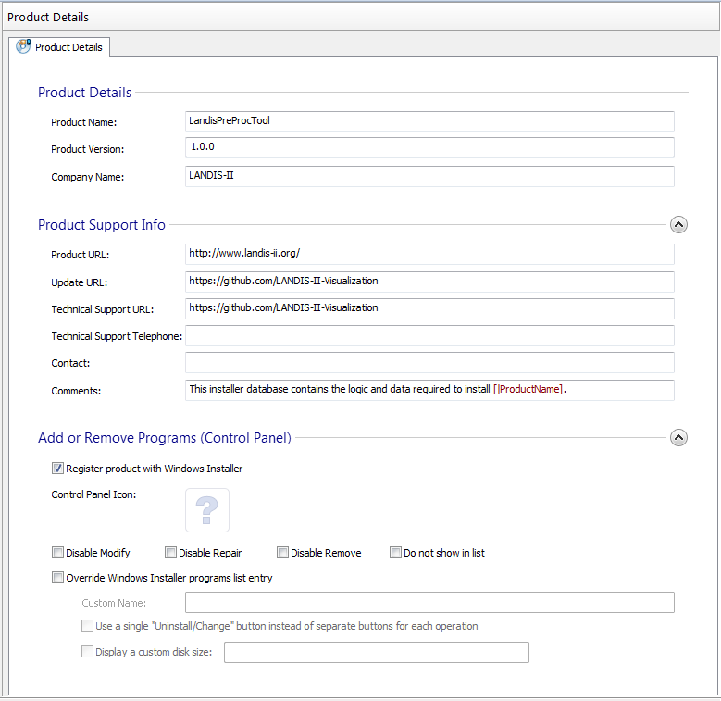
Product Details

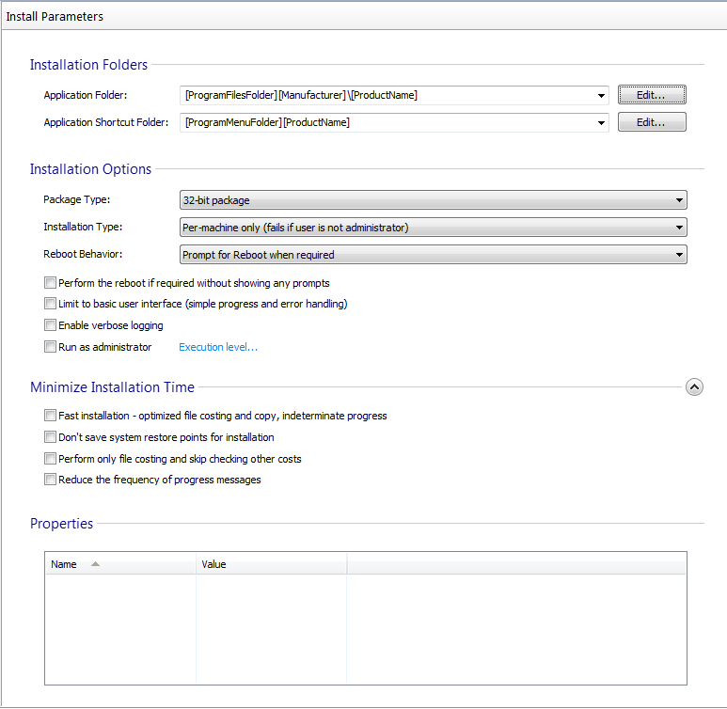

Files and Folders
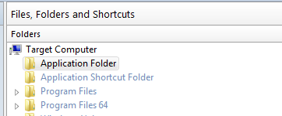
- Application Folder: right click > Add Files...
  - GoTo: LandisVisualizationDevel\PreProcTool\build\dist\PreProcTool
  - Select all Files (Crtl+A) > cklick Open
- Application Folder: right click > Add Folder ...
  - GoTo: LandisVisualizationDevel\PreProcTool\build\dist\PreProcTool
  - select folder: config > click Select Folder
- Repeat for the folders: gdal-data, include, webbase
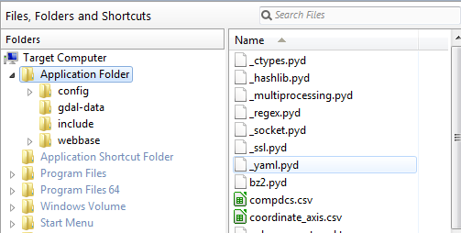


System Changes > Environment:
- add APPDIR to the PATH variable (left)
- create GDAL_DATA variable (right)
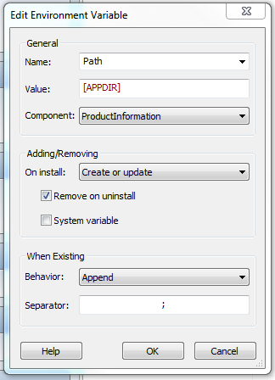
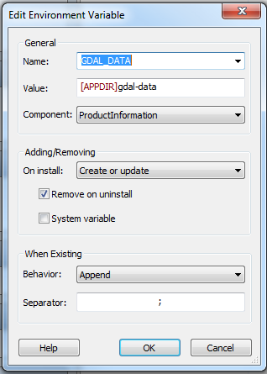
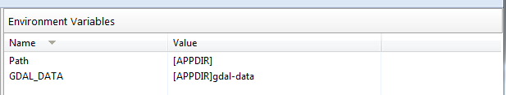

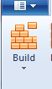
Building an installer
- Start the building process by clicking the Build-Button:

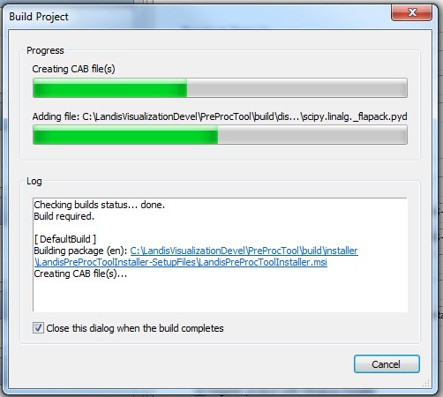

- When done, close the Application
- The Installer is now located at:
\LandisVisualizationDevel\PreProcTool\build\installer\LandisPreProcToolInstaller-SetupFiles\LandisPreProcToolInstaller.msi

